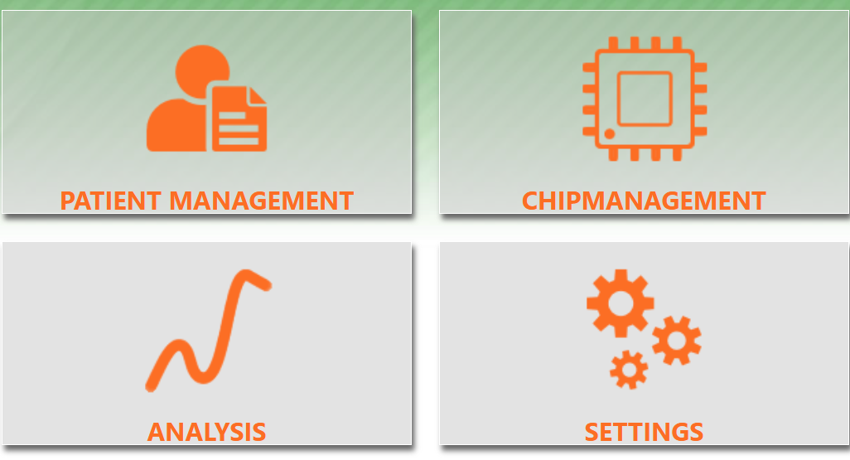
Figure 1: Start overview
1. Select ‘Patient’ Management (Figure 1)
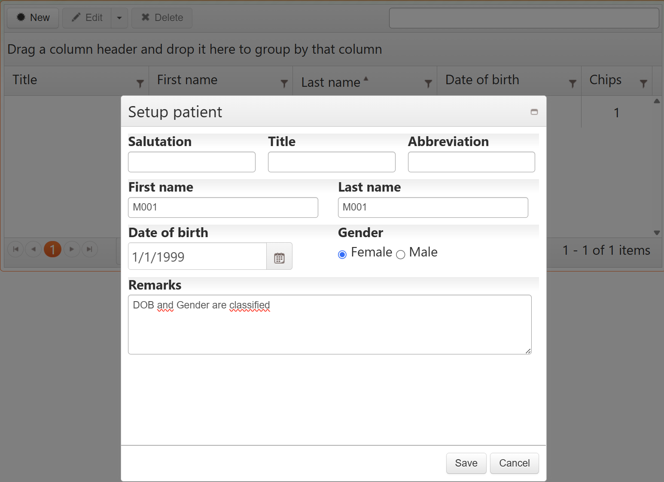
Figure 2: Setup Patient

2. Select ‘New’
3. Add ‘First name’ and ‘Last name’: ‘NumberParticipant’ x2 (Figure 2)
4. Add ‘Date of birth’: 1/1/1999’ for everybody (default) (Figure 2)
5. Leave ‘Gender’ as is on ‘Female’ (default) (Figure 2)
6. ‘Remark’: ADD ‘DOB and Gender are classified’ (Figure 2)
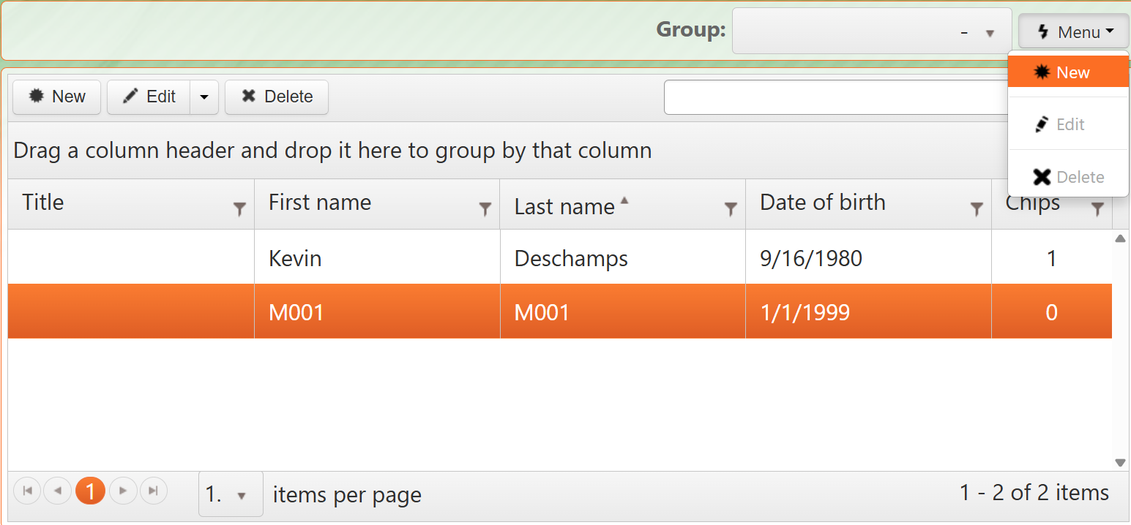
Figure 3: Group setup
7. Go to ‘Group’ – ‘New’ and add ‘Name’: Usual care of Optimal Care (Once)
8. Select participant – Go to ‘Edit’ roll down – ‘Groups’ – ‘Assign Group’ (roll down)
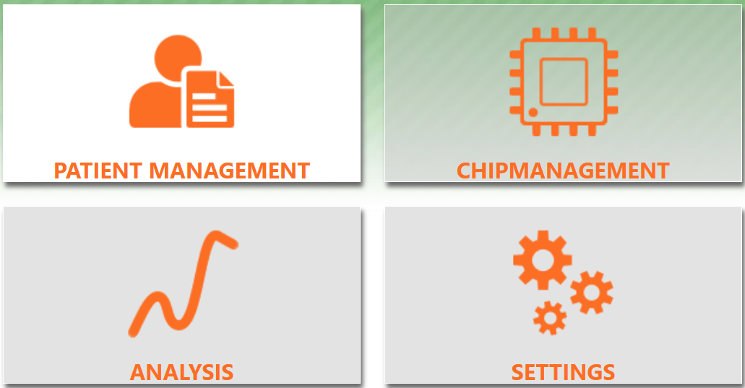
Figure 4: Settings
9. Go to ‘Settings’
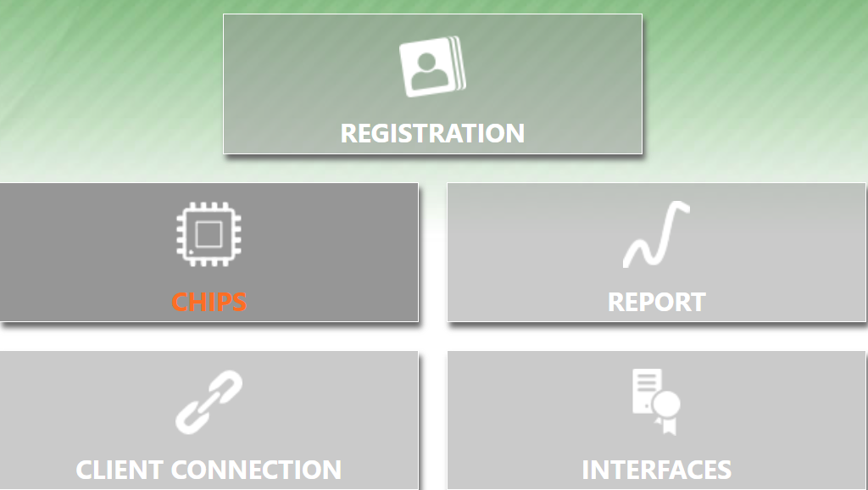
Figure 5: Chips
10. Go to ‘chips’
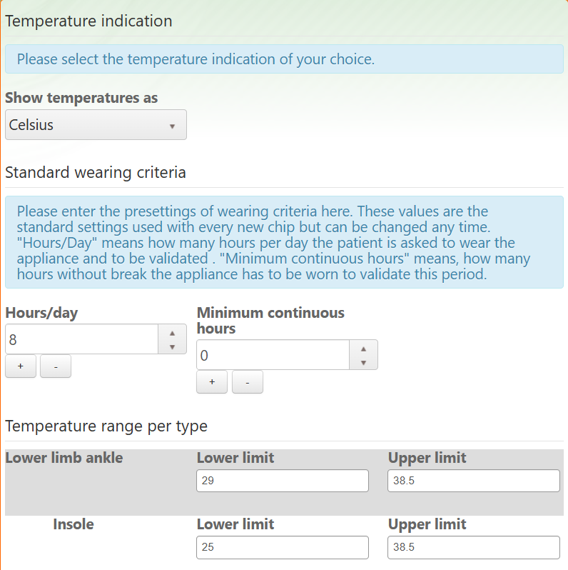
Figure 6: Settings – chips
11. Settings
- Unit: ‘Celsius’
- Hours/day: ‘8’ (Desired standard wearing time)
- Minimum continuous hours: ‘0’ (Default)
- Temperature range: INSOLE (25 à 38.5)
Remark: can be individualised (not applicable in this clinical trial)

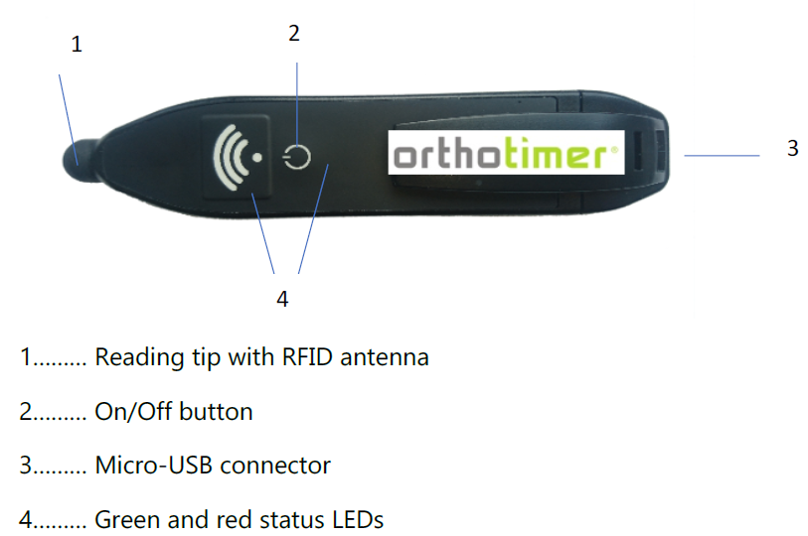
Figure 7: USB-BT- Pen Reader

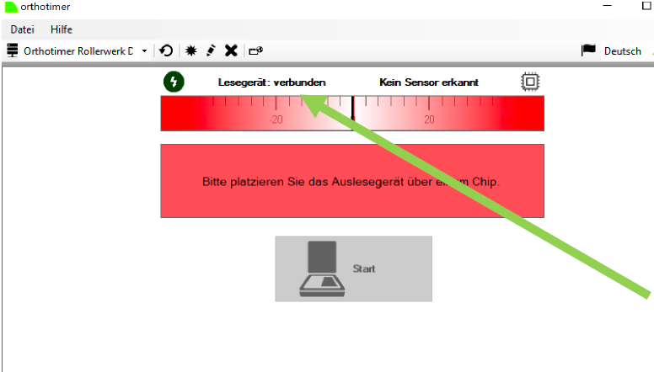
Figure 8: How to activate the sensor
12. Press ‘ON’
13. Connect the Pen Reader to a USB port or select the Bluetooth icon (pen needs to be charged) (Figure 7)
14. Place the tip of the Pen on the sensor: on the ‘O’ of the Orthotimer logo (Green or Orange led lights up)
15. Open the desktop app
16. Look if there is a connection
17. Touch the sensor with the pen è the red bar changes to green (Sensor ‘recognized’)
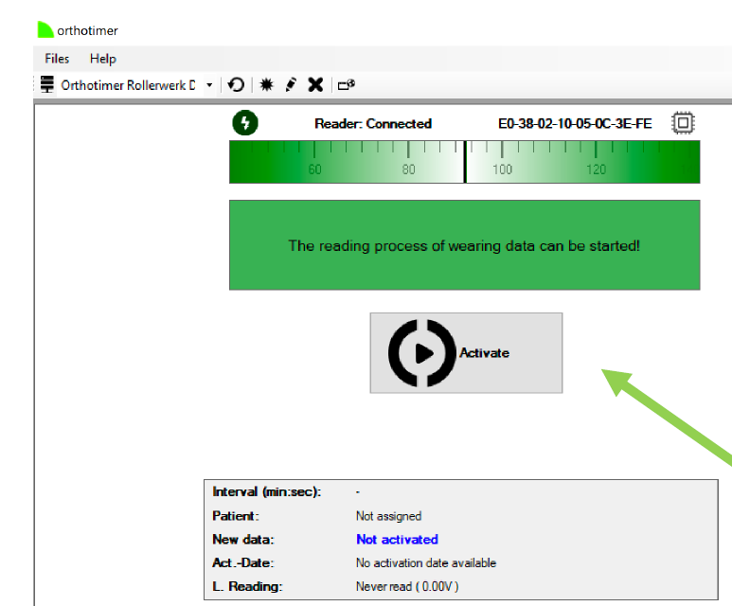
Figure 9: Activation
18. Press ‘Activate’ (Figure 9)
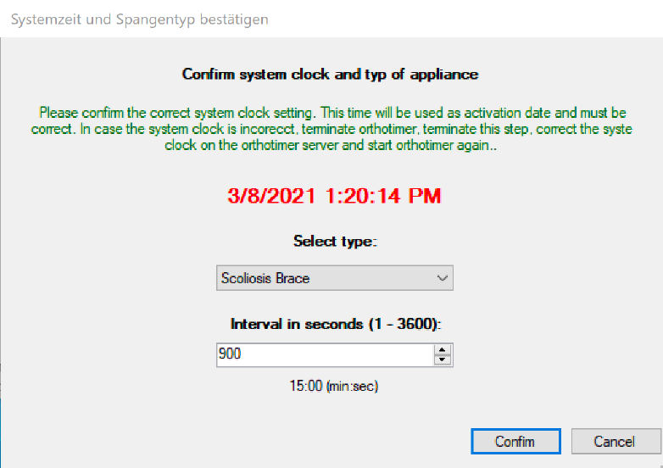
Figure 10: Settings Sensor
19. Select Type: ‘Insole’
20. Interval: ‘900 seconds’ (15 minutes)
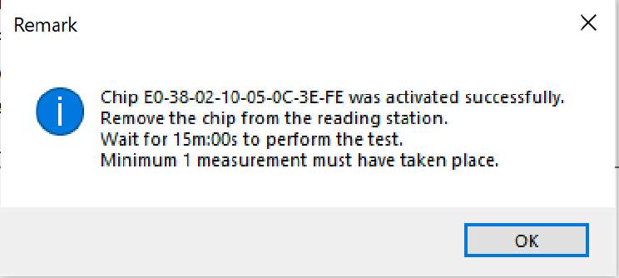
Figure 11: Remark
The sensor is now activated and must perform a test measurement. For the purpose the senor should be removed from reader for a little longer than the measurement interval set.
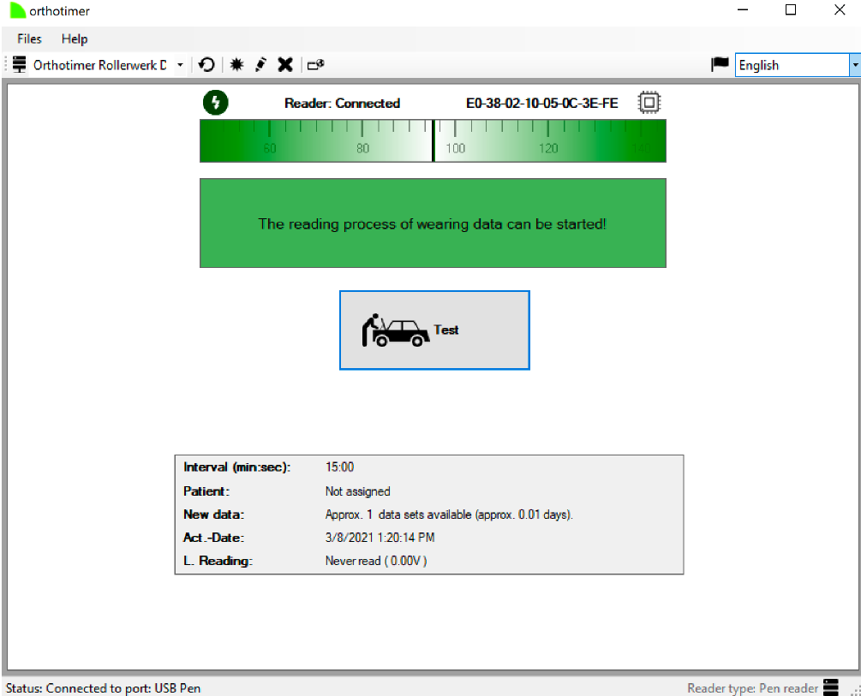
Figure 12: Test
21. Hold the reader on the sensor and press ‘Test’
22. After the first test measurement is downloaded from the senor, a confirmation appears that the test was successful.
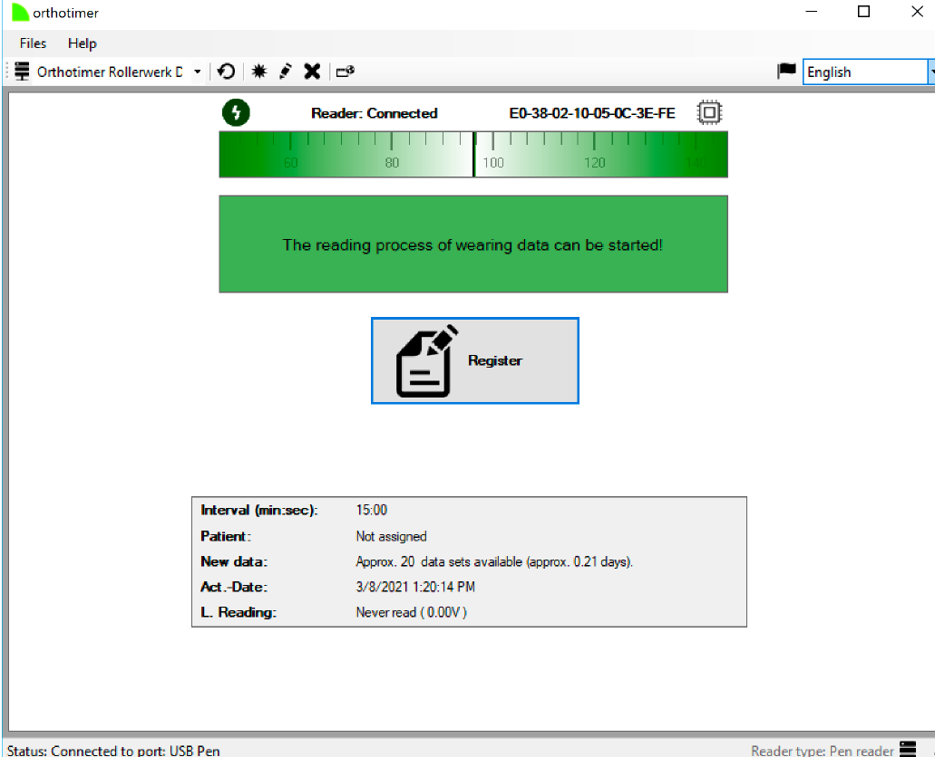
Figure 13: Register
23. Now the sensor will be registered and connected to the patient data. Hold the reader to the sensor and click on Register.
24. Press ‘Yes’ when assigning to participants.
25. Press the ‘*’ in the right upper corner to register a new participant. If already created, select in the search window and Press ‘OK’ (Figure 14)
26. When the registration confirmation appears, click ‘OK’
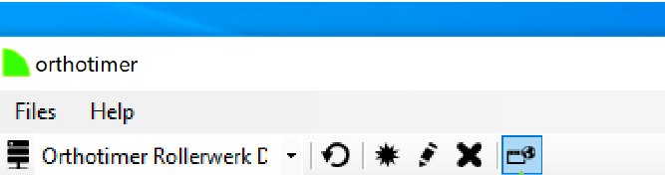
Figure 14: Reader Connected
Here you get the connection to the Orthotimer Cloud
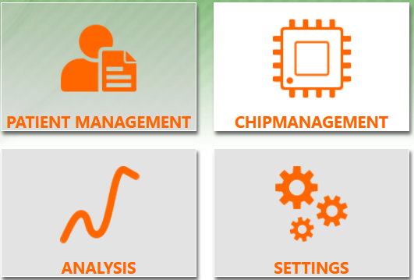
Figure 15: Chipmanagement
27. Go to ‘Chipmanagement’
28. Select the participant
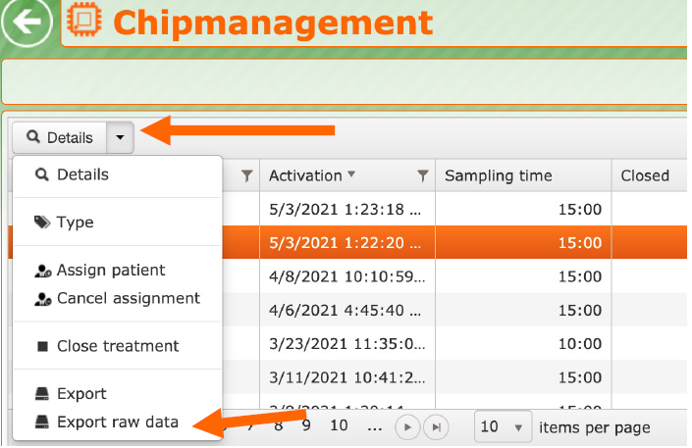
Figure 16: Details
29. Go to roll window next to ‘Details’ and select ‘Export raw data’.

